Ideation Phase
Define the Problem Statements

Date | 10 February 2026
Team ID | LTVIP2026TMIDS67435
Project Name | Weather-Based Prediction Of Wind Turbine Energy Output:  A Next-Generation Approach To Renewable Energy Management.
Maximum Marks | 2 Marks

Customer Problem Statement Template:
To define the core problems faced by renewable energy stakeholders in predicting wind turbine energy output and use those insights to guide the development of an AI-driven forecasting system.
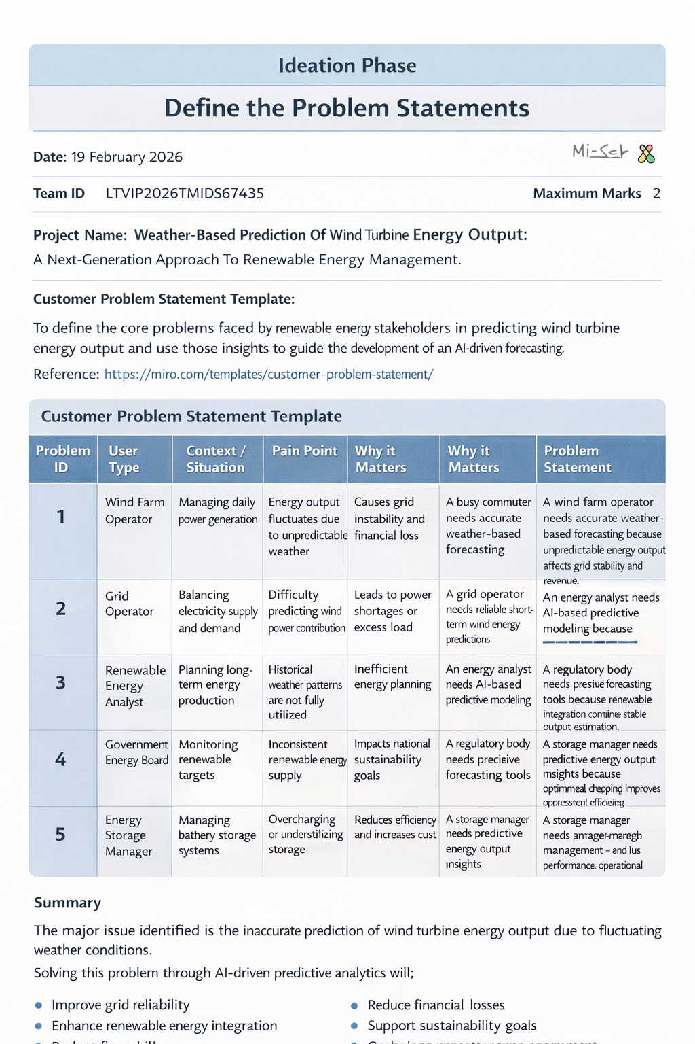
Reference: https://miro.com/templates/customer-problem-statement/
Problem Statements Table

Problem ID | User Type | Context / Situation | Pain Point | Why it Matters | Problem Statement
1 | Wind Farm Operator | Managing daily power generation | Energy output fluctuates due to unpredictable weather | Causes grid instability and financial loss | A wind farm operator needs accurate weather-based forecasting because unpredictable energy output affects grid stability and revenue.
2 | Grid Operator | Balancing electricity supply and demand | Difficulty predicting wind power contribution | Leads to power shortages or excess load | A grid operator needs reliable short-term wind energy predictions because accurate balancing prevents blackouts and overloads.
3 | Renewable Energy Analyst | Planning long-term energy production | Historical weather patterns are not fully utilized | Inefficient energy planning | An energy analyst needs AI-based predictive modeling because manual analysis cannot capture complex weather patterns.
4 | Government Energy Board | Monitoring renewable targets | Inconsistent renewable energy supply | Impacts national sustainability goals | A regulatory body needs precise forecasting tools because renewable integration requires stable output estimation.
5 | Energy Storage Manager | Managing battery storage systems | Overcharging or underutilizing storage | Reduces efficiency and increases cost | A storage manager needs predictive energy output insights because optimized charging improves operational efficiency.

